iOS mOcean SDK

Developer Guide

For iOS Version 2.10.0

Table of Contents

What’s new in 2.10 5

How to move from 2.9.0 to 2.10.0 6

SDK Dependecies 7

SDK Permissions 8

System Requirements 9

Feature list 10

Installing the Ad SDK 11

Add the Latest version of SDK library project to your app 11

Add Frameworks and libraries to your project 12

Set Target Dependencies 13

Install Documentation 14

Types of banners 15

Simple MASTAdView integration 16

Simple Interstitial ad integration 17

Customize MASTAdView 19

Customize view appearance. 19

Customize content. 20

Customize Interstitial ad 21

Customize view appearance. 21

Customize content. 21

Troubleshooting 22

Duplicate symbol compile error 22

Ads not displayed the way you want. 22

MASTAdView Class Reference 23

Overview 23

Tasks 24

Initializing an MASTAdView Object 24

Configuring the MASTAdView 24

Loading the MASTAdView Content 24

Filtering the MASTAdView Content 24

Install Notification 25

Debug the MASTAdView 25

Setting the Delegate 25

Properties 25

adServerUrl 25

additionalParameters 25

advertiserId 26

animateMode 26

area 26

autoCollapse 27

autocloseInterstitialTime 27

carrier 27

city 28

closeButton 28

contentAlignment 28

contentSize 29

country 29

defaultImage 29

delegate 30

groupCode 30

internalOpenMode 31

isLoading 31

keywords 31

latitude 32

logMode 32

longitude 32

maxSize 33

metro 33

minSize 33

premium 34

region 34

showCloseButtonTime 34

showPreviousAdOnError 35

site 35

testMode 35

textColor 36

timeout 36

track 36

type 37

updateTimeInterval 37

zip 38

zone 38

Instance Methods 38

initWithFrame:site:zone: 38

stopEverythingAndNotfiyDelegateOnCleanup 39

update 39

MASTAdInterstitialView Class Reference 40

Overview 40

MASTAdViewDelegate Protocol Reference 41

Overview 41

Tasks 41

Instance Methods 41

adDidEndFullScreen: 41

adShouldOpen:withUrl: 42

adWillStartFullScreen: 42

didClosedAd:usageTimeInterval: 43

didFailToReceiveAd:withError: 43

didReceiveAd: 44

didReceiveThirdPartyRequest:content: 44

ormmaProcess:event:parameters: 45

willReceiveAd: 45

# What’s new in 2.10.0

* There was added the method stopEverythingAndNotfiyDelegateOnCleanup to MASTAdView
* There was set internalOpenMode property default value to FALSE
* The property autoCollapse was added to MASTAdView
* The property showPreviousAdOnError was added to MASTAdView
* The timeout was added to MASTAdView
* Ignore content, if server returned response code != 200
* The maxSize property default value was set to width and height of UI control
* The animation was turned off on expand/resize/close ORMMA methods
* The class AdViewInterstitial was deprecated
* The property showCloseButtonTime was added to MASTAdView
* The property autoCloseInterstitialTime was added to MASTAdView
* The prefix ‘MAST’ was added for all classes
* The sample applications were updated
* The documentation was updated

# How to move from 2.9.0 to 2.10.0

1. Change all names from ‘AdView’, ‘AdInterstitialView’ to ‘MASTAdView’
2. Change all names from ‘AdViewDelegate’,to ‘MASTAdViewDelegate’’
3. AdInterstitialView was deprecated so you must use ‘MASTAdView’ and set value of property showCloseButtonTime or autoCloseInterstitialTime, that is greater than -1.
4. If you use internal browser, you must enable property internalOpenMode.

# SDK Dependecies

* Reachability
* QSUtilities
* UIAlertView-Blocks

You don't need to add these libraries in the project, which is in use. If you want to use a new version of library, you need to replace old version to the ‘/Source/Libs’ folder.

# SDK Permissions

Use SDK requests permission only in one case, when you use the user location coordinate.

If you want to avoid accidentally permission request

1. You should not use the property longitude and latitude.
2. Also you could disable auto detect location by replacing «#define INCLUDE_LOCATION_MANAGER” with “#undef INCLUDE_LOCATION_MANAGER” in MASTAdView.

# System Requirements

* Intel based Mac
* iOS 4.0 - 5.0 SDK
* XCode 4.2

# Feature list

* **HTML/ JS ads**

SDK supports displaying web ads using UIWebView component.

* **Location auto detect**

SDK could automatically detect user location

* **User-Agent auto detect**

SDK automatically detects device User-Agent

* **Ad visibility tracking**

SDK automatically detects ads visibility for controlling updates and video playback

* **Logging**

SDK supports logging.

* **Internal browser**

SDK contains built-in browser for displaying ads in application

* **Rich media**

SDK supports ORMMA level 1.1 and MRAID level 1.0. [See more](http://code.google.com/p/ormma/).

# Installing the Ad SDK

## Add the Latest version of SDK library project to your app

Add the MASTAdView.h, MASTAdDelegate.h header files from Public folder into the SDK sources and library project.

Select Classes, then right-click and select Add Files to “Project Name”...

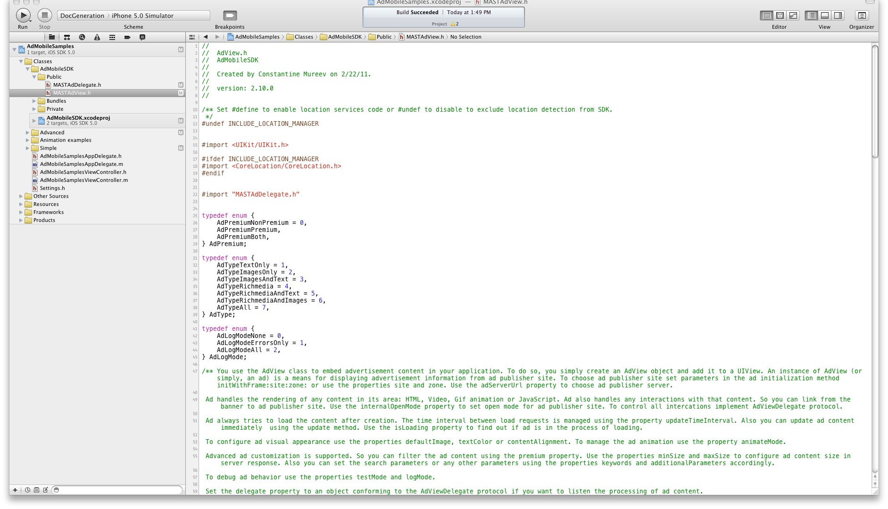

## Add Frameworks and libraries to your project

Add the following frameworks and libraries to you project:

* **libAdMobileSDK.a**
* CoreGraphics
* CoreTelphony
* CoreMotion
* CoreTelphony
* EventKit
* MediaPlayer
* MessageUI
* QuartzCore
* SystemConfiguration

Select Project> Target>Build Phases, then add frameworks to the “Link Binary With Libraries” section

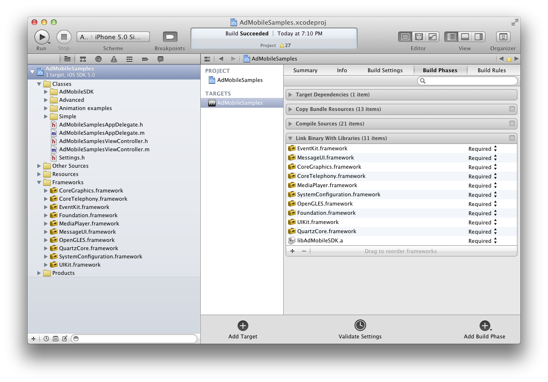

## Set Target Dependencies

Select Project, Target, Build Phases, then add AdMobileSDK target to the “Target Dependencies” section.

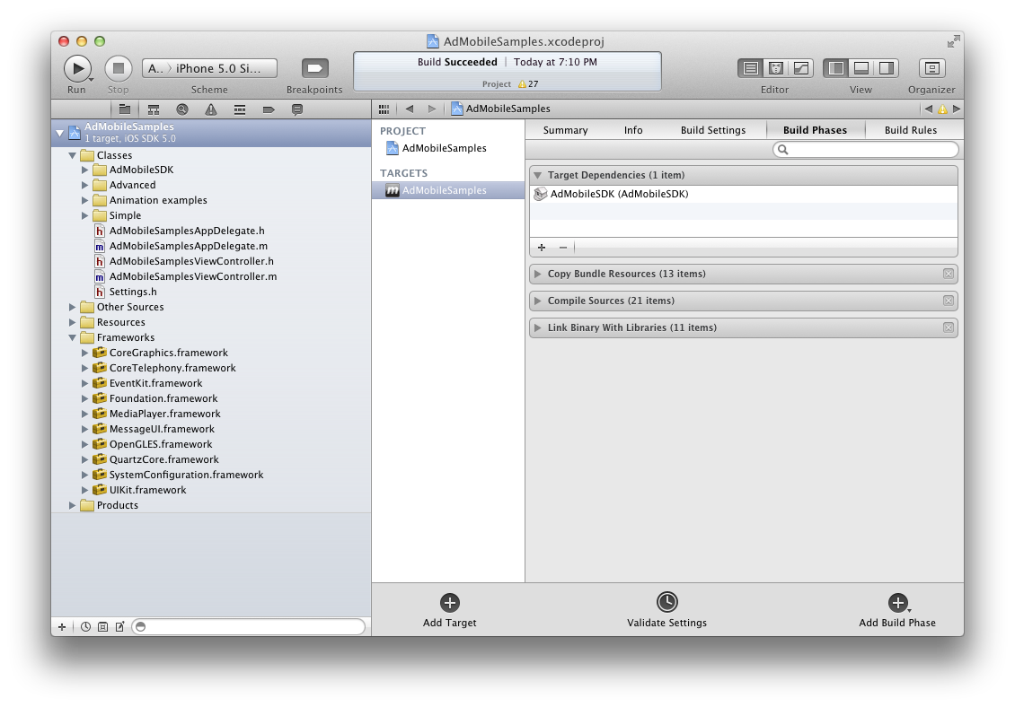

## Install Documentation

SDK includes XCode documentation in the“Documentation\Reference” folder.

Run installdocset.sh script in Terminal.app to copy documentation to XCode or you can use web based version of documentation in html folder

# Types of banners

There are two types of the banner. Simple banner which has the properties showCloseButtonTime and autoCloseInterstitialTime equal -1. The Interstitial banner which has the properties showCloseButtonTime or autoCloseInterstitialTime is greater than -1.

# Simple MASTAdView integration

To add MASTAdView into your application just import MASTAdView.h

#import "MASTAdView.h"

And put initialize code in (void)viewDidLoad method

- (void)viewDidLoad

{

MASTAdView *_adView = [[MASTAdView alloc] initWithFrame:CGRectMake(0, 0, self.view.frame.size.width, 50.0) site:8061 zone:20249];

[self.view addSubview:_adView];

[_adView release];

[super viewDidLoad];

}

See Also:

* For more code samples examine AdMobileSamples application.

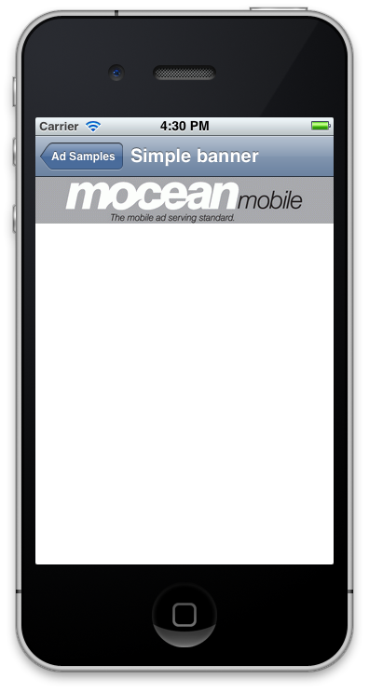

# Simple Interstitial ad integration

To add AdInterstitialView into your application just import MASTAdView.h

#import " MASTAdView.h"

And put initialize code in (void)viewDidLoad method

- (void)viewDidLoad

{

[super viewDidLoad];

MASTAdView *adView = [[MASTAdView alloc] initWithFrame:CGRectMake(0, 20, 320, 460) site:8061 zone:16112];

adView.minSize = CGSizeMake(320, 460);

adView.showCloseButtonTime = 5;

adView.autocloseInterstitialTime = 15;

[self.navigationController.view addSubview:adView];

[adView release];

}

You have to put up one of the properties showCloseButtonTime or autocloseInterstitialTime is greater than -1.

See Also:

* For more code samples examine AdMobileSamples application.

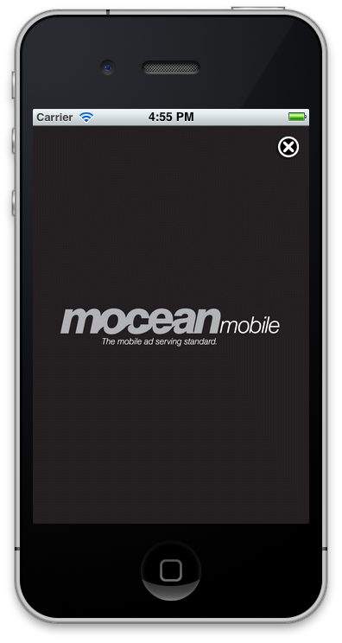

# Customize MASTAdView

## Customize view appearance.

1. By default in MASTAdView, animation is enabled.

To disable default animation set animateMode property to NO.

**Important**: if you need to disable animation, you should specify your own.

2. By default in MASTAdView disable internalOpenMode.

To open the internal browser set internalOpenMode property to YES.

2. Also you can set defaultImage, autoCollapse and showPreviousAdOnError properties that determine what you want to see while the ad is loading, or when the error is uploading.

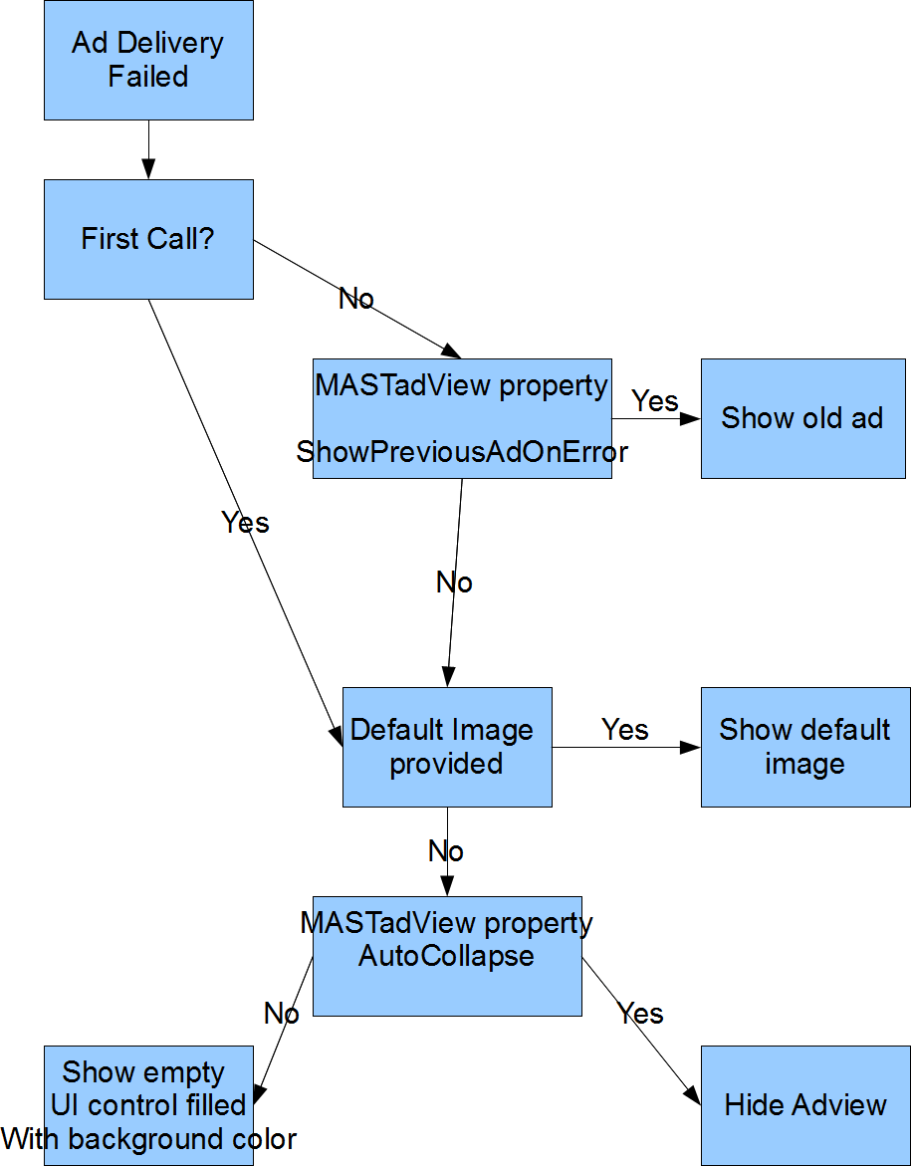

3. Set contentAlignment property to enable auto alignment content in center vertically and horizontally.

**Important**: Richmedia ad does not support this property.

4. Also you can apply default UIView customization such as animation, background color, support different orientations and so on.

## Customize content.

1. By default in SDK disabled location auto detect. If you want to filter content by user’s location, set latitude and longitude property of MASTAdView.

Also you could enable auto detect location by replacing “#undef INCLUDE_LOCATION_MANAGER” with «#define INCLUDE_LOCATION_MANAGER” in MASTAdView.h and adding CoreLocation framework.

**Important:** However do not use Core Location just for advertising, make sure it is used for more beneficial reasons as well. It is both a good idea and part of Apple's guidelines.

2. To add additionally filtration you can set keywords, city, carrier, metro, etc.

# Customize Interstitial ad

## Customize view appearance.

1. By default, there is a white close button of the interstitial ad. You can customize this button yourself.

2. To enable auto close interstitial timer - set time interval autoCloseInterstitial property, in seconds.

3. You can delay close button that is displayed by setting showCloseButtonTime property up.

## Customize content.

See the customize section of MASTAdView

# Troubleshooting

## Duplicate symbol compile error

If you get compile error like this:

/Users/william/Library/Developer/Xcode/DerivedData/theScoreMobile-testApp/Build/Products/Debug-iphoneos/libAdMobileSDK.a(SBJSON.o)"

It means that your project and SDK contain files with same name. In most cases this error appears due to the duplication of some framework. In this case – SBJSON.

To solve this problem you need to remove .m files for all files than cause this error. In this case – keep SBJSON.h and remove SBJSON.m and so on…

## Ads are not displayed the way you want.

1. Set property of the logMode value to AdLogModeErrorsOnly can cause the error. If you see an error that is related to the client, you must remove them yourself, please let us know and send your log.
2. If you don’t not see the errors, you can set the property logMode to AdLogModeAll to get all information about ad. If the message in the log odds with what you see on the screen, please let us know and send your log.
3. Enable testMode to watch how the displayed test ad works in your application.

# MASTAdView Class Reference

|  |  |
| --- | --- |
| **Inherits from** | UIView |
| **Declared in** | MASTAdView.h |

## Overview

You use the [MASTAdView](MASTAdView.html) class to embed advertisement content in your application. To do so, you simply create the [MASTAdView](MASTAdView.html) object and add it to a UIView. An instance of [MASTAdView](MASTAdView.html)(or simply, an ad) is a mean for displaying advertisement information from ad publisher site. To choose ad publisher site, set parameters in the ad initialization methodinitWithFrame:site:zone: or use the properties site and zone. Use the adServerUrl property to choose ad publisher server.

The Ad handles the rendering of any content in its area: HTML, Video, Gif animation or JavaScript. Ad also handles any interactions with that content. So you can link from the banner to ad publisher site. Use the internalOpenMode property to set open mode for ad publisher site. To control all interactions, implement [MASTAdViewDelegate](../Protocols/MASTAdViewDelegate.html) protocol.

Ad always tries to load the content after creation. The time interval between load requests is managed using the property updateTimeInterval. Also you can update ad content immediately using the update method. Use the isLoading property to find out if the ad is in the process of loading or not.

To configure ad visual appearance use the properties defaultImage, autoCollapse, showPreviousAdOnError, textColor or contentAlignment. To manage the ad animation, use the property animateMode.

Advanced ad customization is supported. So you can filter the ad content using the premium property. Use the properties minSize and maxSize to configure ad content size in server response. Also you can set the search parameters or any other parameters using the properties keywords and additionalParameters accordingly.

To debug ad behavior use the properties testMode and logMode.

Set the delegate property to an object conforming to the [MASTAdViewDelegate](../Protocols/MASTAdViewDelegate.html) protocol if you want to listen the processing of ad content.

## Tasks

### Initializing an MASTAdView Object

* – initWithFrame:site:zone:
* – stopEverythingAndNotfiyDelegateOnCleanup

### Configuring the MASTAdView

* site *property*
* zone *property*
* adServerUrl *property*
* timeout *property*
* defaultImage *property*
* animateMode *property*
* closeButton *property*
* contentAlignment *property*
* internalOpenMode *property*
* track *property*
* textColor *property*

### Loading the MASTAdView Content

* isLoading *property*
* updateTimeInterval *property*
* – update
* contentSize *property*

### Filtering the MASTAdView Content

* premium *property*
* type *property*
* keywords *property*
* minSize *property*
* maxSize *property*
* showCloseButtonTime *property*
* autocloseInterstitialTime *property*
* autoCollapse *property*
* showPreviousAdOnError *property*
* additionalParameters *property*
* latitude *property*
* longitude *property*
* country *property*
* region *property*
* city *property*
* area *property*
* metro *property*
* zip *property*
* carrier *property*

### Install Notification

* advertiserId *property*
* groupCode *property*

### Debug the MASTAdView

* testMode *property*
* logMode *property*

### Setting the Delegate

* delegate *property*

## Properties

### adServerUrl

Publisher server url.

@property (retain) NSString *adServerUrl

#### Discussion

Publisher server url.

The default value is <http://ads.AdMobile.mobi/ad>

#### Declared In

MASTAdView.h

### additionalParameters

Custom request parameters.

@property (retain) NSDictionary *additionalParameters

#### Discussion

Custom request parameters.

Use this property to add custom request parameters.

The default value is nil.

**Note:** All keys and objects is need to be kind of NSString Class. For example:

[NSDictionary dictionaryWithObject:@"value" forKey:@"key"]

#### Declared In

MASTAdView.h

### advertiserId

Id of the advertiser for install notification.

@property (assign) NSInteger advertiserId

#### Discussion

Id of the advertiser for install notification.

**Note:** Install notification enabled only if advertiserId and groupCode are specified.

#### Declared In

MASTAdView.h

### animateMode

A Boolean value that determines whether ad animate mode is enabled.

@property BOOL animateMode

#### Discussion

A Boolean value that determines whether ad animate mode is enabled.

Set the value of this property to YES, enable ad animate mode and set it to NO disables this mode.

The default value is YES.

#### Declared In

MASTAdView.h

### area

Area code of a user. For US only.

@property (retain) NSString *area

#### Discussion

Area code of a user. For US only.

The default value is nil.

#### Declared In

MASTAdView.h

### autoCollapse

A Boolean value that determines whether to hide ad in case error

@property BOOL autoCollapse

#### Discussion

A Boolean value that determines whether to hide ad in case error

Use this property to hide ad in case of error.

The default value is YES.

#### Declared In

MASTAdView.h

### autocloseInterstitialTime

Auto close interstitial time interval, in seconds.

@property NSTimeInterval autocloseInterstitialTime

#### Discussion

Auto close interstitial time interval, in seconds.

Setting to 0 will disable auto closing interstitial.

The default value is -1.

#### Declared In

MASTAdView.h

### carrier

User carrier.

@property (retain) NSString *carrier

#### Discussion

User carrier.

The default value is nil.

#### Declared In

MASTAdView.h

### city

City of the device user (with state). For US only.

@property (retain) NSString *city

#### Discussion

City of the device user (with state). For US only.

The default value is nil.

#### Declared In

MASTAdView.h

### closeButton

Close button.

@property (retain) UIButton *closeButton

#### Discussion

Close button.

Set this value to customize close button appearance and behavior.

By default closed button set by SDK with hidden property YES.

**Note:** If you set UIButton, you need to implement close logic too.

**Note:** If you want simply enable default close button set hidden property to NO.

#### Declared In

MASTAdView.h

### contentAlignment

A Boolean value that determines whether content alignment center vertically and horizontally.

@property BOOL contentAlignment

#### Discussion

A Boolean value that determines whether content alignment is centered vertically and horizontally.

Set the value of this property to YES, that enables auto wrapping server response content in HTML table with alignment

The default value is NO.

**Important:** You need to disable animation if you specify your own.

#### Declared In

MASTAdView.h

### contentSize

Size of the ad content to be shown.

@property (readonly) CGSize contentSize

#### Discussion

Size of the ad content must be shown.

Use this property to get the actual size of the ad content. Property value updated after ad content downloaded.

**Note:** If size unavailable (Millennial, Greystripe, iVdopia and other 3rd party SDKs), the property returns CGRectZero.

#### Declared In

MASTAdView.h

### country

The country of visitor. It overrides country detected by IP. It is ISO 3166 to be used for specifying country code.

@property (retain) NSString *country

#### Discussion

The country of visitor. It overrides country detected by IP. It is ISO 3166 to be used for specifying country code.

The default value is nil.

#### Declared In

MASTAdView.h

### defaultImage

Image for unloaded ad state.

@property (retain) UIImage *defaultImage

#### Discussion

Image for unloaded ad state.

Set the value of this property, that determines the ad default image for the unloaded state. In this state the content of the ad is invisible and ad default image is displayed. Without connection to the internet default image will be displayed.

The default value is nil.

#### Declared In

MASTAdView.h

### delegate

The receiver’s delegate.

@property (assign) id<MASTAdViewDelegate> delegate

#### Discussion

The receiver’s delegate.

The [MASTAdView](MASTAdView.html) is sent messages when content is processing. The delegate must adopt the [MASTAdViewDelegate](../Protocols/MASTAdViewDelegate.html) protocol. The delegate is not retained.

**Important:** Before releasing an instance of [MASTAdView](MASTAdView.html) for which you have set a delegate, you must firstly set its delegate property to nil. This can be done, for example, in your dealloc method.

#### See Also

* [MASTAdViewDelegate](../Protocols/MASTAdViewDelegate.html) is the protocol Reference for the optional methods, this @property delegate may be implemented.

#### Declared In

MASTAdView.h

### groupCode

Group code for install notification.

@property (retain) NSString *groupCode

#### Discussion

Group code for install notification.

**Note:** Install notification enabled only if advertiserId and groupCode are specified.

#### Declared In

MASTAdView.h

### internalOpenMode

A Boolean value that determines whether an ad internal browser is enabled.

@property BOOL internalOpenMode

#### Discussion

A Boolean value that determines whether an ad internal browser is enabled.

Set the value of this property to NO disables internal browser, so after linking from the banner the ad publisher site will be opened in Safari.

To handle opening/closing internal browser use [MASTAdView](MASTAdView.html) delegate or viewWillAppear/viewWillDisappear methods of UIViewController.

The default value is NO.

#### Declared In

MASTAdView.h

### isLoading

A Boolean value that determines whether ad is in the process of loading.

@property (readonly) BOOL isLoading

#### Discussion

A Boolean value that determines whether the ad is in the process of loading.

#### Declared In

MASTAdView.h

### keywords

Keywords for search ads.

@property (retain) NSString *keywords

#### Discussion

Keywords for search ads.

Use this property to search ads. The values are delimited by commas.

The default value is nil.

#### Declared In

MASTAdView.h

### latitude

User location latitude value.

@property (retain) NSString *latitude

#### Discussion

User location latitude value.

Use this property to set latitude. The value @“” will stop coordinates of auto-detection and coordinates will not be sent to the server. Any other values also will stop the coordinates of auto-detection but coordinates will be sent to the server.

The default value is auto-detected by locationManager and sent to the server.

#### Declared In

MASTAdView.h

### logMode

AdLogMode value determines log level.

@property AdLogMode logMode

#### Discussion

AdLogMode value that determines log level.

typedef enum { AdLogModeNone = 0, AdLogModeErrorsOnly = 1, AdLogModeAll = 2, } AdLogMode;

Setting of the property value to AdLogModeNone disables ads logging. AdLogModeErrorsOnly – enables logging errors only. AdLogModeAll – enables logging errors and info

The default value is AdLogModeErrorsOnly.

#### Declared In

MASTAdView.h

### longitude

User location longitude value.

@property (retain) NSString *longitude

#### Discussion

User location longitude value.

Use this property to set longitude. The value @“” will stop the coordinates of the auto-detection and these coordinates will not be sent to the server. Any other values also will stop the coordinates of auto-detection but these coordinates will be sent to server.

The default value is auto-detected by locationManager and sent to server.

#### Declared In

MASTAdView.h

### maxSize

Maximal size of the ad content can be shown.

@property CGSize maxSize

#### Discussion

Maximal size of the ad content can be shown.

Use this property to set the maximal size of the ad content and server response will be close to this size.

#### Declared In

MASTAdView.h

### metro

Metro code of a user. For US only.

@property (retain) NSString *metro

#### Discussion

Metro code of a user. For US only.

The default value is nil.

#### Declared In

MASTAdView.h

### minSize

Minimal size of the ad content can be shown.

@property CGSize minSize

#### Discussion

Minimal size of the ad content can be shown.

Use this property to set the minimal size of the ad content and server response will be close to this size.

#### Declared In

MASTAdView.h

### premium

Ad premium filter.

@property AdPremium premium

#### Discussion

Ad premium filter.

typedef enum { AdPremiumNonPremium = 0, AdPremiumPremium, AdPremiumBoth, } AdPremium;

Use this property to filter the content of ad by premium status.

The default value is AdPremiumNonPremium.

#### Declared In

MASTAdView.h

### region

Region of visitor. ISO 3166-2 is used for United States and Canada and FIBS 10-4 is used for other countries.

@property (retain) NSString *region

#### Discussion

Region of visitor. ISO 3166-2 is used for United States and Canada and FIBS 10-4 is used for other countries.

The default value is nil.

#### Declared In

MASTAdView.h

### showCloseButtonTime

Shows close button delay time interval, in seconds.

@property NSTimeInterval showCloseButtonTime

#### Discussion

Shows close button delay time interval, in seconds.

Setting to 0 will show close button immediately.

The default value is -1.

#### Declared In

MASTAdView.h

### showPreviousAdOnError

A Boolean value determines whether to show the previous ad in case of error

@property BOOL showPreviousAdOnError

#### Discussion

A Boolean value that determines whether to show previous ad in case of error

Use this property to show previous ad in case of error.

The default value is YES.

#### Declared In

MASTAdView.h

### site

Id of the publisher site.

@property (assign) NSInteger site

#### Discussion

Id of the publisher site.

Value setting of this property determines the id of the publisher site, so switching between publisher sites is possible. The default value is copied from parameter site of ad initialization method.

#### Declared In

MASTAdView.h

### testMode

A Boolean value that determines whether ads test mode is enabled. Setting the value of this property to YES enables ads test mode and setting it to NO disables ads test mode.

@property BOOL testMode

#### Discussion

A Boolean value that determines whether ads test mode is enabled. Set the value of this property to YES enables ads test mode and set it to NO disables ads test mode.

The default value is NO.

#### Declared In

MASTAdView.h

### textColor

Color of ad text links.

@property (retain) UIColor *textColor

#### Discussion

Color of ad text links.

The default value is nil.

**Note:** Alpha value ignored.

#### Declared In

MASTAdView.h

### timeout

Maximum server response time.

@property (assign) NSInteger timeout

#### Discussion

Maximum server response time.

Specify timeout of ad call. This tells the ad server the maximum time you are willing to wait for an ad response.

The default value is 1000ms (milleseconds).

The max value is 3000ms (milleseconds).

#### Declared In

MASTAdView.h

### track

A Boolean value that determines whether the ad track is enabled.

@property BOOL track

#### Discussion

A Boolean value that determines whether ad track is enabled.

If set to YES, the ad server will send a client side impression tracking pixel with each ad, regardless of if the campaign has this property set or not. Impressions will not be counting if this pixel does not render on the device.

The default value is NO.

#### Declared In

MASTAdView.h

### type

Ad type filter.

@property AdType type

#### Discussion

Ad type filter.

typedef enum { AdTypeTextOnly = 1, AdTypeImagesOnly = 2, AdTypeImagesAndText = 3, AdTypeRichmedia = 4, AdTypeRichmediaAndText = 5, AdTypeRichmediaAndImages = 6, AdTypeAll = 7, } AdType;

Use this property to filter the content of ad by type.

#### Declared In

MASTAdView.h

### updateTimeInterval

Update time interval, in seconds.

@property NSTimeInterval updateTimeInterval

#### Discussion

Update time interval, in seconds.

The value of this property determines time interval between ads updating. This interval is counted after finish loading content, so the ad will start updating only after loading is finished and time interval is passed.

Setting value can be ranged from 0 to 5 and will apply 5 seconds to prevent too fast ad updates.

Setting to 0 will stop updates. All positive values enable updates.

The default value is 120.

#### Declared In

MASTAdView.h

### zip

Zip/Postal code of user (note: parameter is all caps). For US only.

@property (retain) NSString *zip

#### Discussion

Zip/Postal code of user (note: parameter is all caps). For US only.

The default value is nil.

#### Declared In

MASTAdView.h

### zone

Id of the publisher zone.

@property (assign) NSInteger zone

#### Discussion

Id of the publisher zone.

Set the value of this property determines the id of the publisher zone, so switching between publisher zones is possible. The default value is copied from parameter zone of ad initialization method.

#### Declared In

MASTAdView.h

## Instance Methods

### initWithFrame:site:zone:

Initializes and returns an [MASTAdView](MASTAdView.html) object having the given frame, site and zone.

- (id)initWithFrame:(CGRect)frame site:(NSInteger)site zone:(NSInteger)zone

#### Parameters

frame

A rectangle specifies the initial location and size of the ad view in its superview’s coordinates.

site

A value that specifies the id of ad publisher site.

zone

A value that specifies the id of ad publisher zone.

#### Return Value

Returns an initialized [MASTAdView](MASTAdView.html) object or nil if the object could not be successfully initialized.

#### Discussion

Initializes and returns an [MASTAdView](MASTAdView.html) object having the given frame, site and zone.

#### Declared In

MASTAdView.h

### stopEverythingAndNotfiyDelegateOnCleanup

Use this method, if you want to close the ad quickly and clear all resource.

- (void)stopEverythingAndNotfiyDelegateOnCleanup

#### Discussion

Use this method, if you want to close the ad quickly and clear all resource.

#### Declared In

MASTAdView.h

### update

Starts to update the ad content immediately.

- (void)update

#### Discussion

Starts to update the ad content immediately.

Call this method if you want to update the ad content immediately (for example, after setting the  site and the zone or changing adServerUrl). If an ad is in the process of loading it will be interrupted.

# MASTAdInterstitialView Class Reference

|  |  |
| --- | --- |
| **Inherits from** | [MASTAdView](../Classes/MASTAdView.html) : UIView |
| **Declared in** | MASTAdInterstitialView.h |

## Overview

The [MASTAdInterstitialView](MASTAdInterstitialView.html) class is deprecated. You must use [MASTAdView](../Classes/MASTAdView.html) class and set showCloseButtonTime or autocloseInterstitialTime properties valuethat is greater than -1.

# MASTAdViewDelegate Protocol Reference

|  |  |
| --- | --- |
| **Conforms to** | NSObject |
| **Declared in** | MASTAdDelegate.h |

## Overview

The [MASTAdViewDelegate](MASTAdViewDelegate.html) protocol defines methods that is the delegate of a [MASTAdView](../Classes/MASTAdView.html) object and can optionally be implemented to receive notifications from the ad.

## Tasks

* – willReceiveAd:
* – didReceiveAd:
* – didReceiveThirdPartyRequest:content:
* – didFailToReceiveAd:withError:
* – adWillStartFullScreen:
* – adDidEndFullScreen:
* – adShouldOpen:withUrl:
* – didClosedAd:usageTimeInterval:
* – ormmaProcess:event:parameters:

## Instance Methods

### adDidEndFullScreen:

Sent after an ad view is finished displaying internal browser.

- (void)adDidEndFullScreen:(id)sender

#### Parameters

sender

The ad view has finished displaying internal browser.

#### Discussion

Sent after an ad view finished displaying internal browser.

#### Declared In

MASTAdDelegate.h

### adShouldOpen:withUrl:

Sent before an ad view will start to open URL.

- (BOOL)adShouldOpen:(id)sender withUrl:(NSURL *)url

#### Parameters

sender

The ad view that is about to open URL.

url

The URL that should be opened in internal or external browser.

#### Return Value

Returns YES to allow SDK open browser otherwise returns NO.

#### Discussion

Sent before an ad view will start to open URL.

Implement this method with return NO value if you want to control opening ads by your self.

This method is optional. If you do not implement this method, the SDK accepts YES as return value.

**Important:** This method may not calling on 3rd party SDKs (Millennial, Greystripe, iVdopia, …)

#### Declared In

MASTAdDelegate.h

### adWillStartFullScreen:

Sent before an ad view will start to display internal browser.

- (void)adWillStartFullScreen:(id)sender

#### Parameters

sender

The ad view that is about to display internal browser.

#### Discussion

Sent before an ad view will start to display internal browser.

**Important:** This method is called after adShouldOpen:withUrl: returns YES or not implemented.

**Important:** This method is not called an opening ads in Safari (internalOpenMode set to NO). To handle this behavior it’s necessary to implement the UIApplicationDelegate protocol

#### Declared In

MASTAdDelegate.h

### didClosedAd:usageTimeInterval:

Sent after an ad view is closed and tracks the usage time of ad interstitial view.

- (void)didClosedAd:(id)sender usageTimeInterval:(NSTimeInterval)usageTimeInterval

#### Parameters

sender

The ad view was closed.

usageTimeInterval

The usage time interval of ad view.

#### Discussion

Sent after an ad view closed and tracks the usage time of ad interstitial view.

#### Declared In

MASTAdDelegate.h

### didFailToReceiveAd:withError:

Sent if an ad view failed to load ad content.

- (void)didFailToReceiveAd:(id)sender withError:(NSError *)error

#### Parameters

sender

The ad view that is failed during the loading of the ad content.

error

The error that occurred during loading.

#### Discussion

Sent if an ad view is failed for loading of the ad content.

The same method can be invoked if the server does not currently advertising.

#### Declared In

MASTAdDelegate.h

### didReceiveAd:

Sent after an ad view has finished loading ad content.

- (void)didReceiveAd:(id)sender

#### Parameters

sender

The ad view has finished loading.

#### Discussion

Sent after an ad view finished loading of the ad content.

#### Declared In

MASTAdDelegate.h

### didReceiveThirdPartyRequest:content:

Sent if SDK received client side third party campaign.

- (void)didReceiveThirdPartyRequest:(id)sender content:(NSDictionary *)content

#### Parameters

sender

The ad view that receives 3rd party ad content.

content

The dictionary of strings (key/values) for third party. You can start processing this content from @“type” key for determining ads type.

#### Discussion

Sent if SDK received client side third party campaign.

Generally, this method is called if the SDK can’t display the ads due to the reliance on a third party. For example: AdMob, Rhythm or SmartAdServer

**Important:** The SDK will never display the ads which trigger this method! They are used to call the third party SDKs in your app.

#### Declared In

MASTAdDelegate.h

### ormmaProcess:event:parameters:

Sent after an ad process ORMMA command.

- (void)ormmaProcess:(id)sender event:(NSString *)event parameters:(NSDictionary *)parameters

#### Parameters

sender

The ad view that is about to process ORMMA event.

event

The string with name of the event.

parameters

The Dictionary with parameters from event.

#### Discussion

Sent after an ad process ORMMA command.

**Important:** Implement this method only if you want to add the additional logic for event. By default SDK already implemented all methods and your code could conflict with SDK

#### Declared In

MASTAdDelegate.h

### willReceiveAd:

Sent before an ad view will begin loading the ad content.

- (void)willReceiveAd:(id)sender

#### Parameters

sender

The ad view that is about to load ad content.

#### Discussion

Sent before the an ad view will begin loading ad content.